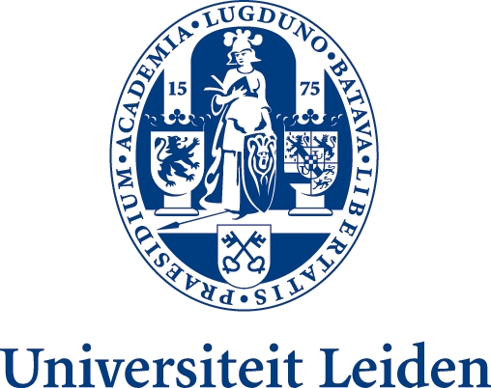
TRADE MARK LAW INSTITUTE
Leiden-Nijmegen-Groningen-Amsterdam

3rd TLI SYMPOSIUM
TRADE MARK USE ON THE INTERNET
9-10 March 2012
Faculty of Law, Radboud University of Nijmegen

PROGRAMME

Friday, 9 March 2012

13.30 Registration and coffee
14:00 Welcome and Information on Trademark Law Institute
Prof. Antoon Quaedvlieg, Trademark Law Institute (Nijmegen)
Aim of the Conference & Approach

14:15 Part 1: Confusion after Google
Chair: Prof. Charles Gielen, Trademark Law Institute (Groningen)
14:15 Introduction I. Liability of Providers and operators of electronic market places. Ebay/l’Oréal
Prof. Matthias Leistner, Rheinische Friedrich-Wilhelms-Universität Bonn
14:40 Introduction II. Google France: ‘vagueness’ vs ads which users ‘erroneously perceive as emanating from the proprietor’
Prof. Paul Torremans, University of Nottingham
15:00 Discussion
16:00 Coffee Break

16:15 Part 2: Goodwill Protection and Online Use
Chair: Prof. Antoon Quaedvlieg, Trademark Law Institute (Nijmegen)
16:15 Introduction I. “Goodwill online”: (l’Oréal – Google -) Interflora
Judge Robin Jacob
16:40 Introduction II. Dilution and degeneration in online environments
Prof. Dirk Visser, Trademark Law Institute (Leiden)
17:00 Discussion
18:00 Summary and conclusion
20:00 Conference Dinner

Saturday, 10 March 2012

9:00 Part 3: Exceptions
Chair: Prof. Martin Senftleben, Trademark Law Institute (Amsterdam, Free University)
9:00 Introduction I. Confusion, Essential Function, Function Theory
Prof. Tobias Cohen Jehoram, Erasmus University Rotterdam
9:25 Introduction II. External exceptions: Comparative advertising, freedom of speech, fair use
Prof. Ansgar Ohly, University of Bayreuth
9:45 Discussion
10:30 Coffee Break

10:45 Part 4: Unfair Competition and Liability Issues
Chair: Prof. Dirk Visser, University of Leiden
10:45 Introduction I. Can 10bis Paris Convention, UCP Directive supplement TM protection?
Prof Anselm Kamperman Sanders, Maastricht University
11:05 Introduction II. (subject still to be established)
Prof Wushuang HUANG, East China University of Political Science and Law, Shanghai
11:25 Discussion

12:15 Conclusion and summary of main results

12:45 Closing and Information on Future Projects
Prof. Charles Gielen, Trademark Law Institute (Groningen)
13:00 Conference Closing Lunch

