Trademark Law Institute

Conference ‘Referential, Descriptive and Other Fair Use of Trademarks’

1-2 December
Amsterdam Law School
Institute for Information Law (IViR)
, Roeterseiland Campus, Nieuwe Achtergracht 166

From the airport:

(1) take a train to Amsterdam Centraal

(2) From Amsterdam Centraal, take Metro 51 (direction Isolatorweg), Metro 53 (direction Gaasperplas) or Metro 54 (direction Gein) to station ‘Weesperplein’

(3) From Weesperplein, it is only a short walk to the Roeterseiland Campus:

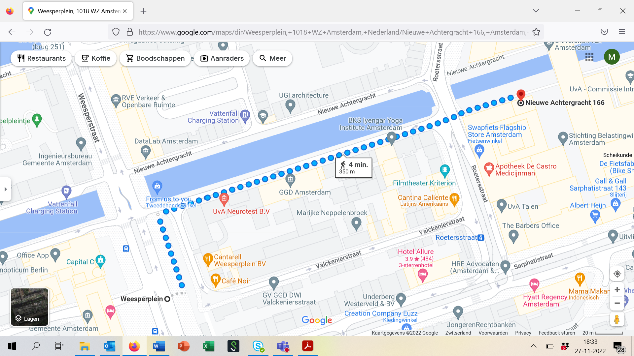

Programme

Venue: IViR Library, Roeterseiland Campus, Building A, 5th floor, Nieuwe Achtergracht 166

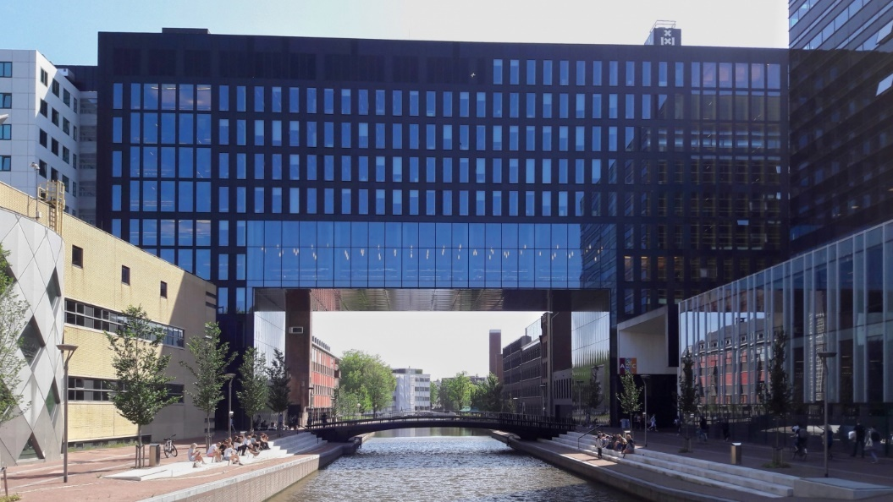

When you enter the building through the main entrance, please turn right to the law faculty (Building A) and take the lift to the 5th floor. Leaving the lift, you have the IViR Library on your right.

Thursday, December 1, 2022

13.30 Registration and coffee

14:00 Welcome and Information on Trademark Law Institute
Prof. Martin Senftleben, Trademark Law Institute (Amsterdam)
Aim of the Conference
General Approach

14:15 Part 1: Referential Use Defence: Conceptual Contours, Fields of Application, Proper Scope

Chair: Prof. Tobias Cohen Jehoram, Trademark Law Institute (Rotterdam)

14:15 Introduction I: Comparative Advertising, Keyword Advertising and Other Modern Forms of Advertising
Anke Moerland, Maastricht
14:25 Introduction II: Parody and Other Forms of Artistic Expression
Sabine Jacques, University of East Anglia
14:35 Discussion

15:45 Coffee Break

16:15 Part 2: Descriptive and Non-Distinctive Use Defence: Conceptual Contours, Fields of Application, Proper Scope

Chair: Charlotte Vrendenbarg, Trademark Law Institute (Leiden)

16:15 Introduction I: Descriptive and Non-Distinctive Use Defences in EU Trademark Law
Prof. Anna Tischner, Jagiellonian University Krakow
16:25 Introduction II: (Absence of) Descriptive and Non-Distinctive Use Defences in EU Geographical Indications Law
Prof. Annette Kur, Max Planck Institute, Munich
16:35 Introduction III: Limitations of Protection in Geographical Indications Law from an International and Comparative Law Perspective
Prof. Irene Calboli, Texas A&M, Fort Worth
16:45 Discussion

18:00 Closing

19:00 Conference Dinner

Café Restaurant De Ysbreeker, Weesperzijde 23, Amsterdam, https://www.deysbreeker.nl/

From the IViR Library, this is a 10-15 minutes walk:

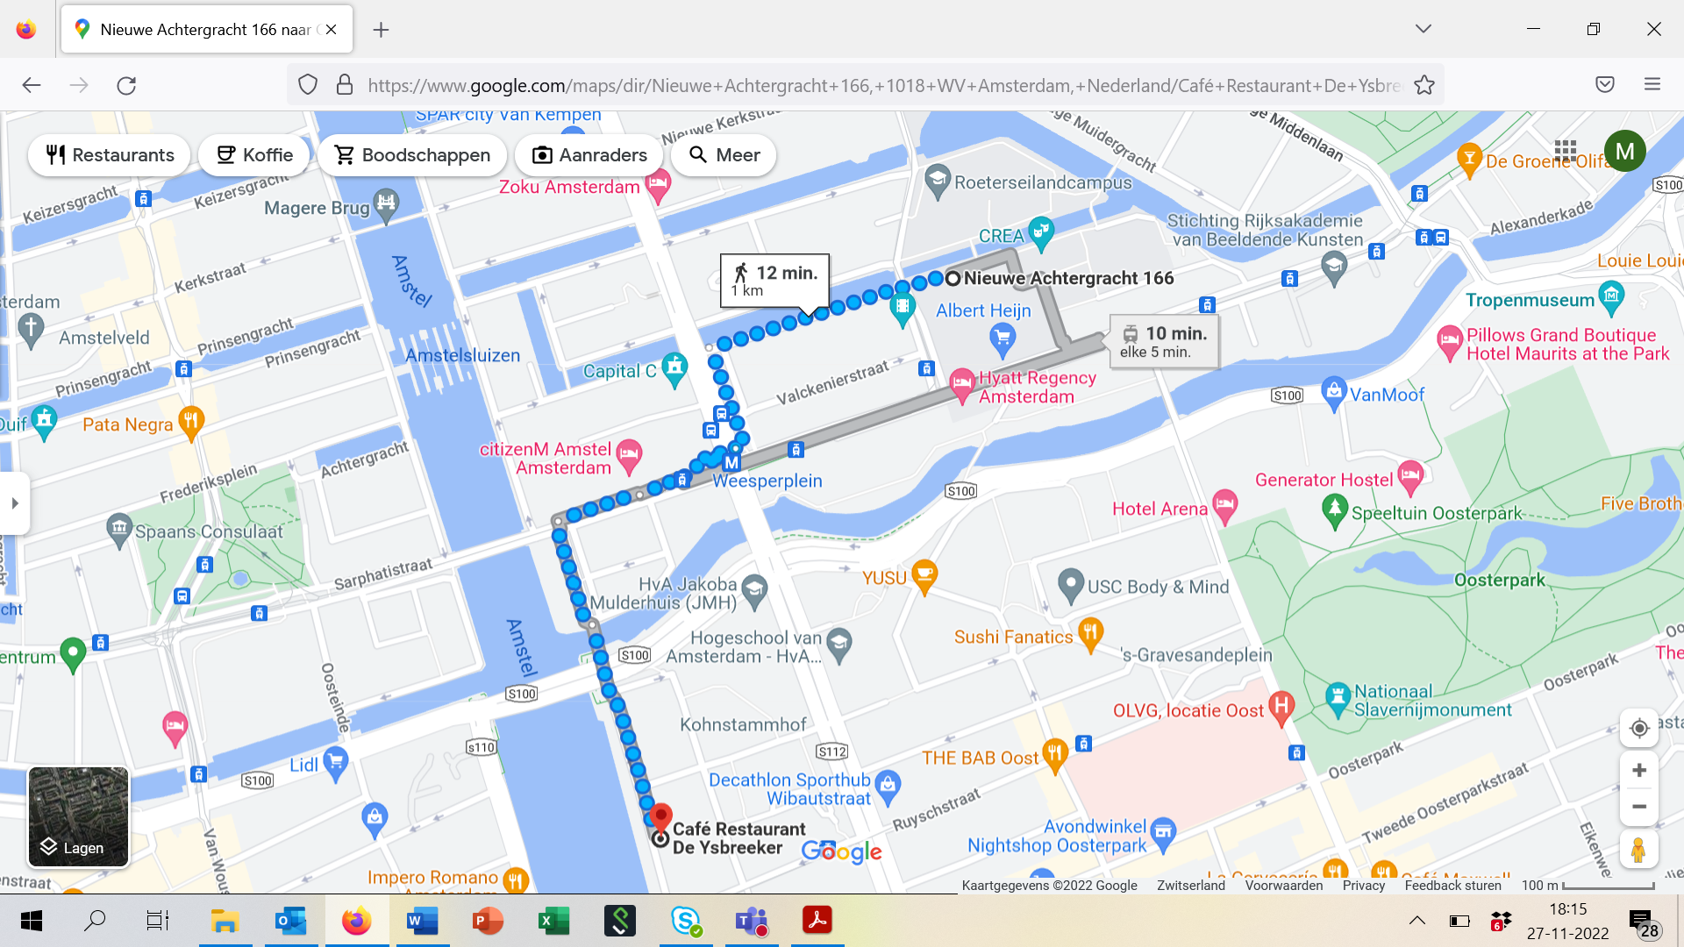

Friday, December 2, 2022

Venue: IViR Library, Roeterseilandcampus, Building A, 5th floor, Nieuwe Achtergracht 166 (same as the day before)

9:30 Part 3: Coexistence with Other Rights in Distinctive Signs: Conceptual Contours, Fields of Application, Proper Scope

Chair: Prof. Antoon Quaedvlieg, Trademark Law Institute (Nijmegen)

9:30 Introduction I: Prior Trademarks and Later Geographical Indications from an International and Comparative Perspective
Wolf Meier-Ewert, World Trade Organization
9:40 Introduction II: Trademarks, Trade Names and Other Earlier Rights in a Particular Locality
Prof. Marco Ricolfi, Turin
9:50 Introduction III: Later Trademarks in a Part of the EU that is Remote From the Area Where an EUTM has Been Used
Prof. Ansgar Ohly, LMU, Munich
10:00 Discussion

11:00 Coffee Break

11:15 Part 4: Honest Practices in Industrial or Commercial Matters: Conceptual Contours and Impact on Trademark Limitations

Chair: Prof. Anselm Kamperman Sanders, Trademark Law Institute (Maastricht)

11:15 Introduction I: Proviso of Honest Practices From an International and Comparative Perspective
Marcus Höpperger, World Intellectual Property Organization
11:25 Introduction II: Circularity of Honest Practices Analysis in CJEU Case Law
Prof. Łukasz Żelechowski, Warsaw
11:35 Introduction III: Human Rights Guidelines for Determining Honest Practices in Case of Use for Artistic Expression
Prof. Christophe Geiger, Luiss, Rome
11:45 Discussion

12:45 Closing and suggestions concerning future projects

13:00 Conference Lunch

In case you participate in the inaugural lecture:

16:00 Doors open at the Old Lutheran Church (Aula of the University of Amsterdam), address: Singel 411/corner Spui (if you are a professor participating in the cortège, it is good to be present around 16:00, please walk through the church hall to the toga room).

16:30 Start inaugural lecture (duration: 45-60 minutes)

18:00 Reception at the Koninklijke Industrieele Groote Club, address: Dam 27 (5-minute walk from the Aula, https://www.igc.nl/)

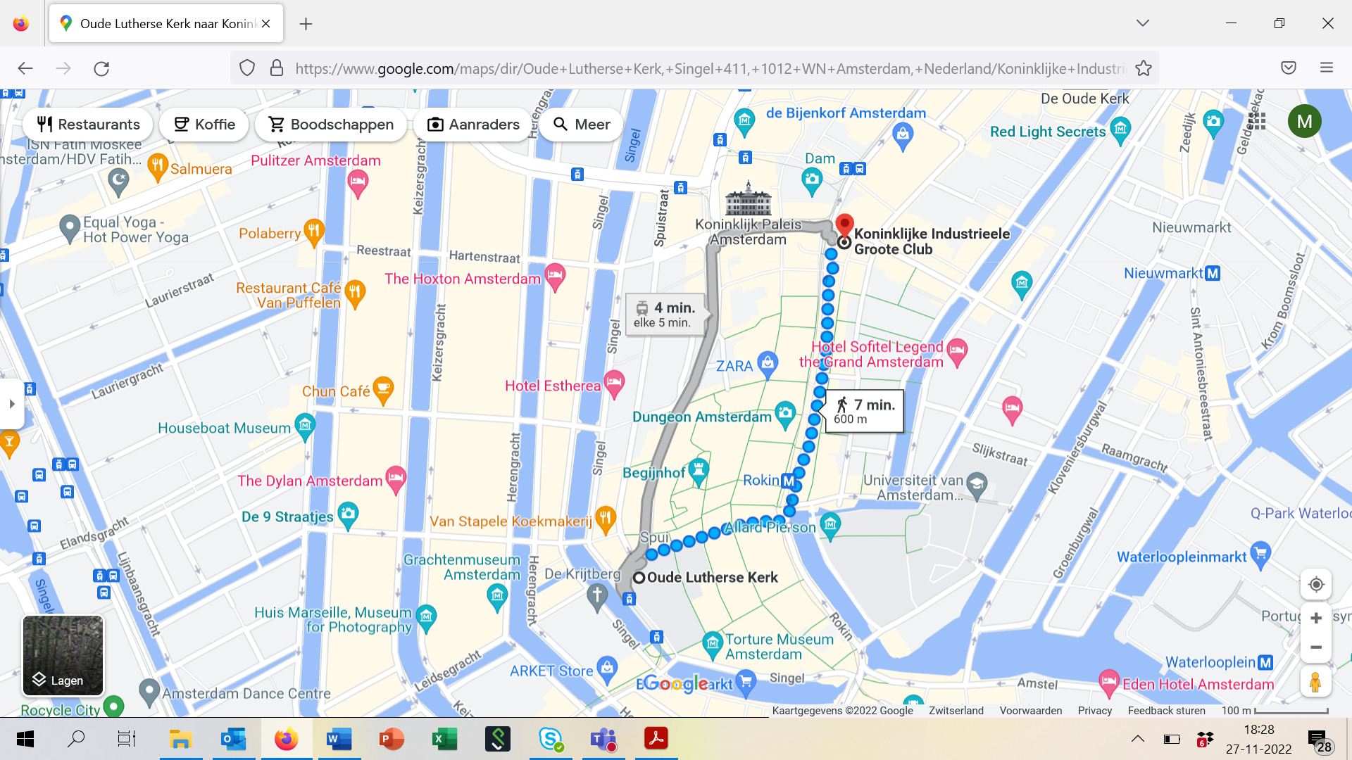

List of Participants

Anemaet, Lotte - Vrije Universiteit Amsterdam, The Netherlands
Appl, Clemens - Danube University Krems, Austria
Brancusi, Lavinia - University of Warsaw, Poland
Bronneman, Marjolein - Benelux Office for Intellectual Property, The Netherlands
Calboli, Irene - Texas A&M University, United States
Chalmers Hoynck van Papendrecht, Roderick - Erasmus University, The Netherlands
Cohen Jehoram, Tobias - Trademark Law Institute, Erasmus University, The Netherlands
Derclaye, Estelle - University of Nottingham, United Kingdom
Fhima, Ilanah - University College London, United Kingdom
Geiger, Christophe - Luiss University, Rome, Italy
Gervais, Daniel - Vanderbilt Law School, United States
Gielen, Charles - Trademark Law Institute, University of Stellenbosch, South Africa
Gompel van, Stef - Vrije Universiteit Amsterdam, The Netherlands
Homar, Philipp - Johannes Kepler University Linz, Austria
Höpperger, Marcus - World Intellectual Property Organization, Geneva, Switzerland
Hout van den, Gertjan - Trademark Law Institute, University of Groningen, The Netherlands
Jacob, Robin - University College London, United Kingdom
Jacques, Sabine - University of East Anglia, United Kingdom
Kamperman Sanders, Anselm - Maastricht University, The Netherlands
Kur, Annette - Max Planck Institute for Innovation and Competition, Germany
Mansani, Luigi - University of Parma, Italy
Meier-Ewert, Wolf - World Trade Organization, Geneva, Switzerland
Moerland, Anke - Maastricht University, The Netherlands
Mühlendahl von, Alexander – Bardehle Pagenberg, Munich, Germany
Ohly, Ansgar - Ludwig Maximilians University München, Germany
Quaedvlieg, Antoon - Trademark Law Institute, Radboud University, The Netherlands
Ricolfi, Marco - University of Turin, Italy
Sakulin, Wolfgang - Sakulin Advocatuur, Rotterdam, The Netherlands
Senftleben, Martin - Trademark Law Institute, University of Amsterdam, The Netherlands
Tischner, Anna - Jagiellonian University Krakow, Poland
Torremans, Paul - University of Nottingham, United Kingdom
Vrendenbarg, Charlotte - Trademark Law Institute, Leiden University, The Netherlands
Zelechowski, Lukasz - University of Warsaw, Poland

