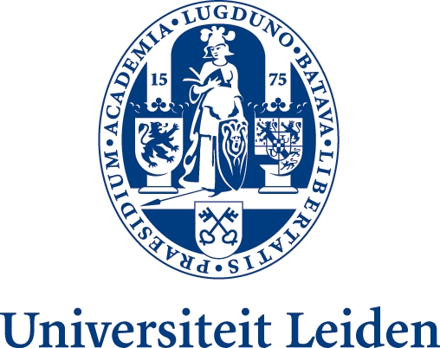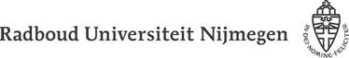

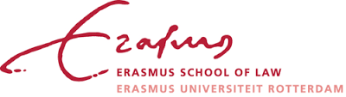

TRADE MARK LAW INSTITUTE
Leiden-Nijmegen-Groningen-Amsterdam-Rotterdam

8th TLI SYMPOSIUM:
Trade marks, honest trade, dilution
Faculty of Law, Radboud University of Nijmegen

PROGRAMME

13 April 2018: TRADE MARK LAW AND HONEST TRADE PRACTICES.
14 April 2018: THE CONCEPT OF DILUTION AND THE FUNCTION THEORY.

Friday, 13 April 2018

TRADE MARK LAW AND HONEST TRADE PRACTICES.

13.30 Registration and coffee
14:00 Welcome
Antoon Quaedvlieg, Prof at Radboud University, Nijmegen
Aim of the Conference & Approach

14:15 Part 1: Honest trade practices and the goodwill function

Chair: Charles Gielen, Prof. Extraordinary at Stellenbosch University, South-Africa
14:20 Introduction I.
Prof. Joachim Bornkamm (to be confirmed)
14:35 Introduction II.
Prof. Anselm Kamperman Sanders
14:50 Discussion
16:00 Coffee Break

16:15 Part 2: Honest trade practices and the essential function of the trade mark
Chair: Martin Senftleben, Prof. at Free University, Amsterdam
16:15 Introduction I.
Prof. Luigi Mansani
16:30 Introduction II.
Prof. Jean-Luc Piotraut
16:45 Discussion
18:00 Summary and conclusion
20:00 Conference Dinner

Saturday, 14 April 2018

THE CONCEPT OF DILUTION AND THE FUNCTION THEORY

9:30 Part 3: The rationale of the protection against dilution

Chair: Dirk Visser, Prof. at University of Leiden
9:35 Intro I
Dr. Anke Moerland
9:50 Intro II.
Dr. Claes Granmar
10:05 Discussion
11.00 Coffee Break

11:15 Part 4: Evidence of – a risk of - a change in economic behaviour
Chair: Tobias Cohen Jehoram, Prof. at Erasmus School of Law, Rotterdam
11:20 Introduction I.
Prof. Andrew Griffiths
11:35 Introduction II.
Dr. Łukasz Żelechowski
11:50 Discussion

12:45 Closing and Information on Future Projects
Prof ( Trademark Law Institute)

13:00 Conference Closing Lunch

